Project Design Phase
Proposed Solution Documentation

Proposed Solution Template
Project team shall fill the following information for the proposed BlogNest solution.
Date | 22 September 2026
Team ID | SWIT-2026-2748
Project Name | AI BlogNest API
Maximum Marks | 2 Marks

Proposed Solution: BlogNest
BlogNest is a full-stack blogging platform designed to bring content creation, editing, review, publishing, comment moderation, security and AI-assisted content generation into one structured system. It uses role-based access so that Admin, Editor, Author and Reader activities are controlled according to their responsibilities.
S.No. | Parameter | Description
1 | Problem Statement (Problem to be solved) | Existing blogging workflows can become fragmented when users need separate tools for writing, editing, categorizing, moderation, publishing and content assistance. Manual content preparation takes time, comment moderation can be difficult, and unsafe user input can create security risks. BlogNest addresses the need for a single, secure and organized blogging workflow.
2 | Idea / Solution description | BlogNest provides a role-based blogging environment with CRUD post management, tags and categories, draft/review/publishing workflows, comment moderation and authenticated reader interaction. The backend follows a structured API architecture with routing, controllers and Mongoose models connected to MongoDB. AI services support blog generation from thematic inputs and produce summaries, abstracts and metadata.
3 | Novelty / Uniqueness | The solution combines normal blog management with integrated AI assistance and security-focused workflows. Its distinctive features include role-based route guarding, controlled content states, comment moderation flags, input sanitization against XSS and unsafe NoSQL-style parameters, AI-based blog generation and an automatic summarization workflow within the same platform.
4 | Social Impact / Customer Satisfaction | BlogNest can reduce the effort required to publish useful digital content and provides a clearer workflow for authors and editors. Readers receive organized published material and authenticated commenting. Moderation and sanitization help create a safer interaction environment, while AI assistance can help users prepare first drafts and summaries more efficiently.
5 | Business Model (Revenue Model) | BlogNest can follow a freemium or subscription model. Basic blogging and reading features can remain free, while premium plans can provide higher AI usage, advanced analytics, additional storage, custom domains or enhanced publishing tools. Organizations or educational institutions can also use a paid deployment or institutional licensing model.
6 | Scalability of the Solution | The platform can scale by separating the API, database and AI services. MongoDB can support increasing content volumes, while role-based controllers and modular services allow additional features to be added without redesigning the whole system. Future versions can include cloud deployment, caching, file/object storage, background AI jobs, search and analytics.

BlogNest Proposed Solution – System Diagram
The diagram shows how users and roles interact with the BlogNest application, secure backend, data layer, AI content services, content-management functions and security controls.
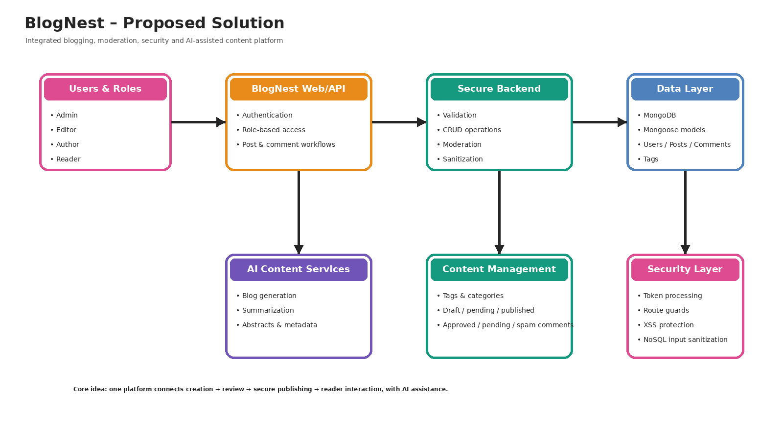

Key Features of the Proposed Solution
- Role-based route guarding with token processing for Admin, Editor, Author and Reader access.
- CRUD blog engine for creating, editing, publishing and managing posts.
- Tag and category organization for easier content discovery.
- Comment moderation with approved, pending and spam states.
- Input sanitization and validation to reduce XSS and unsafe NoSQL-style parameter manipulation.
- LLM-based blog generation from thematic inputs.
- Summarization engine for abstracts and metadata summaries.
- Headless API architecture using routing, controller workflows, Mongoose models and MongoDB.

Expected Result
The proposed BlogNest solution creates a single workflow for writing, reviewing, publishing and interacting with blog content. It combines usability, role-based control, moderation, security and AI assistance so that the platform can support both academic and general blogging use cases.

